TSB (updated for FY 2023 employer reporting)
Proposed Pension Note Disclosures – TSB Employer Units
(Based on Illustration 3 in GASB No. 68 – Note disclosures for employers participating in a cost-sharing plan – also reference par .74 to .80 of GASB 68)

A. THE FOLLOWING IS AN ADDITION TO THE SUMMARY OF SIGNIFICANT ACCOUNTING POLICIES
Pensions
For purposes of measuring the net pension liability (asset), deferred outflows of resources and deferred inflows of resources related to pensions, and pension expense, information about the fiduciary net position of the Teachers’ Survivors Benefit plan (TSB) and the additions to/deductions from TSB fiduciary net position have been determined on the same basis as they are reported by TSB. For this purpose, benefit payments (including refunds of employee contributions) are recognized when due and payable in accordance with the benefit terms. Investments are reported at fair value.
B. THE FOLLOWING INFORMATION IS FOR INCLUSION IN THE EMPLOYER’S PENSION NOTES
Note X. Defined Benefit Pension Plan
General Information about the Pension Plan
Plan description - Certain employees of the (Name of Employer Unit / School District) participate in a cost-sharing multiple-employer defined benefit pension plan - the Teachers’ Survivors Benefit plan - administered by the Employees’ Retirement System of the State of Rhode Island (System). Under a cost-sharing plan, pension obligations for employees of all employers are pooled and plan assets are available to pay the benefits of the employees of any participating employer providing pension benefits through the plan, regardless of the status of the employers’ payment of its pension obligation to the plan. The plan provides a survivor benefit to public school teachers in lieu of Social Security since not all school districts participate in Social Security.
The System issues a publicly available financial report that includes financial statements and required supplementary information for the plans. The report may be obtained at http://www.ersri.org.

Eligibility and plan benefits - the plan provides a survivor benefit to public school teachers in lieu of Social Security since not all school districts participate in the plan. Specific eligibility criteria and the amount of the benefit is subject to the provisions of Chapter 16-16 of the Rhode Island General Laws which are subject to amendment by the General Assembly. Spouse, parents, family and children’s benefits are payable following the death of a member. A spouse shall be entitled to benefits upon attaining the age of sixty (60) years. Children’s benefits are payable to the child, including a stepchild or adopted child of a deceased member if the child is unmarried and under the age of eighteen (18) years or twenty-three (23) years and a full time student, and was dependent upon the member at the time of the member’s death. Family benefits are provided if at the time of the member’s death the surviving spouse has in his or her care a child of the deceased member entitled to child benefits. Parents benefits are payable to the parent or parents of a deceased member if the member did not leave a widow, widower, or child who could ever qualify for monthly benefits on the member’s wages and the parent has reached the age of 60 years, has not remarried, and received support from the member.
In January, a yearly cost-of-living adjustment for spouse’s benefits is paid and based on the annual social security adjustment.
Survivors are eligible for benefits if the member has made contributions for at least six months prior to death or retirement.
The TSB plan provides benefits based on the highest salary at the time of retirement of the teacher. Benefits are payable in accordance with the following table:
Highest Annual Salary | Basic Monthly  Spouses’s Benefit
$17,000 or less | $ 825.00
$17,001 to $25,000 | $ 962.50
$25,001 to $33,000 | $ 1,100.00
$33,001 to $40,000 | $ 1,237.50
$40,001 and over | $ 1,375.00

Benefits payable to children and families are equal to the spousal benefit multiplied by the percentage below:
Parent and 1 Child | Parent and 2 or more Children | One Child Alone | Two Children Alone | Three or more Children  Alone | Dependent  Parent
150% | 175% | 75% | 150% | 175% | 100%

Contributions - The contribution requirements of active employees and the participating school districts were established under Chapter 16-16 of the Rhode Island General Laws, which may be amended by the General Assembly. The cost of the benefits provided by the plan are two percent (2%) of the member’s annual salary up to but not exceeding an annual salary of $11,500; one-half (1/2) of the cost is contributed by the member by deductions from his or her salary, and the other half (1/2) is contributed and paid by the respective school district by which the member is employed. These contributions are in addition to the contributions required for regular pension benefits.
The (Name of Employer Unit / School District) contributed $X,XXX,XXX, $X,XXX,XXX and $X,XXX,XXX for the fiscal years ended June 30, 2023, 2022 and 2021, respectively, equal to 100% of the required contributions for each year. (Contribution amount for FY 2022 must agree with amount on Page 5 of “Schedule of Employer Allocations” and the amount for FY 2023 must agree with amounts reported by ERSRI).

Pension Asset, Pension Expense, and Deferred Outflows of Resources and Deferred Inflows of Resources

At June 30, 2023 the (Name of Employer Unit / School District) reported an asset of $X,XXX,XXX (Source: column entitled “Ending Net Pension Liability (Asset)” on “Schedule of Pension Amounts by Employer”) for its proportionate share of the net pension asset related to its participation in TSB. The net pension asset was measured as of June 30, 2022, the measurement date, and the total pension liability used to calculate the net pension asset was determined by an actuarial valuation as of June 30, 2021 rolled forward to June 30, 2022. The (Name of Employer Unit / School District) proportion of the net pension asset was based on its share of contributions to the TSB for fiscal year 2022 relative to the total contributions of all participating employers for that fiscal year. At June 30, 2022 the (Name of Employer Unit / School District) proportion was X.XX% (Source: column entitled “Proportionate Share” on “Schedule of Pension Employer Allocations”).

For the year ended June 30, 2023 the (Name of Employer Unit / School District) recognized pension expense of $(XXX,XXX) – a decrease in the net pension asset. (Source: column entitled “Total Pension Expense” on “Schedule of Pension Amounts by Employer”). At June 30, 2023 the (Name of Employer Unit / School District reported deferred outflows of resources and deferred inflows of resources related to pensions from the following sources:

Deferred outflows of resources
Contributions subsequent to the measurement date
Difference between expected and actual experience
Changes in assumptions
Net difference between projected and actual earnings on pension plan investments
Changes in proportion and differences between employer contributions and proportionate share of contributions
Deferred inflows of resources
Changes in proportion and differences between employer contributions and proportionate share of contributions
Net difference between projected and actual earnings on pension plan investments
Difference between expected and actual experience
Total

Deferred outflow and inflow data is contained in columns on pages 6 and 7 in “Schedule of Pension Amounts by Employer” except for contributions subsequent to the measurement date.

$X,XXX,XXX reported as deferred outflows of resources related to pensions resulting from the (Name of Employer Unit / School District) contributions in fiscal year 2023 subsequent to the measurement date will be recognized as an addition to the net pension asset in the subsequent period. Other amounts reported as deferred inflows of resources related to pensions will be recognized in pension expense as follows:

Year ended June 30:
2024 | Amounts from Schedule B
2025
2026
2027
2028

Dollar amounts for each year to be obtained from OAG Schedule B – Schedule of Pension Amounts by Employer - use line for your entity.

Actuarial Assumptions - the total pension liability was determined using the following actuarial assumptions, applied to all periods included in the measurement:

Inflation 2.50%

Salary increases 3.0% to 13.0%

Investment rate of return 7.0%

Mortality – Variants of the PUB (10) Tables for Healthy and Disabled Retirees, projected with Scale Ultimate MP16.
Cost of living adjustment – eligible survivors receive a yearly cost of living adjustment based on the annual social security adjustment – for valuation purposes, a 2.5% cost of living adjustment is assumed.

The actuarial assumptions used in the June 30, 2021 valuation and the calculation of the total pension liability at June 30, 2022 were consistent with the results of an actuarial experience study performed as of June 30, 2019 for the six year period ended June 30, 2019 as approved by the System’s Board on May 22, 2020.

The long-term expected rate of return best-estimate on pension plan investments was determined by the actuary using a building-block method. The actuary started by calculating best-estimate future expected real rates of return (expected returns net of pension plan investment expense and inflation) for each major asset class, based on a collective summary of capital market expectations from 40 sources. The June 30, 2022 expected arithmetic returns over the long-term (20 years) by asset class are summarized in the following table:

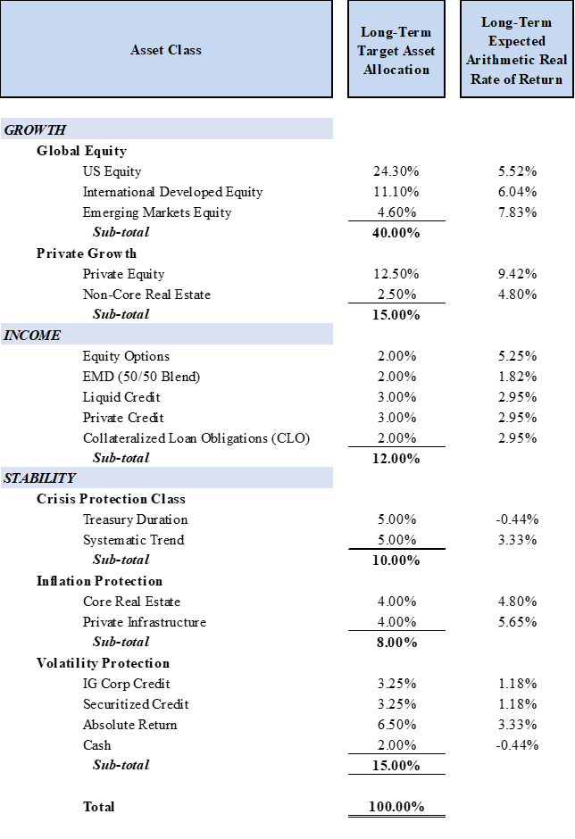
These return assumptions are then weighted by the target asset allocation percentage, factoring in correlation effects, to develop the overall long-term expected rate of return best-estimate on an arithmetic basis.

Discount rate - the discount rate used to measure the total pension liability was 7.0 percent. The projection of cash flows used to determine the discount rate assumed that contributions from plan members will be made at the current contribution rate and that contributions from the employers will be made at statutorily required rates, actuarially determined. Based on those assumptions, the pension plan’s fiduciary net position was projected to be available to make all projected future benefit payments of current plan members. Therefore, the long-term expected rate of return on pension plan investments was applied to all periods of projected benefit payments to determine the total pension liability.

Sensitivity of the net pension liability (asset) to changes in the discount rate - the following presents the proportionate share of the net pension liability (asset) calculated using the discount rate of 7.0 percent as well as what the net pension liability (asset) would be if it were calculated using a discount rate that is 1-percentage-point lower or 1-percentage-point higher than the current rate.

1.00% Decrease  (6.0%) | Current Discount Rate  (7.0%) | 1.00 Increase  (8.0%)

Dollar amounts for each year to be obtained from OAG issued – Schedule of Pension Amounts by Employer – Schedule B - use line for your entity.

Pension plan fiduciary net position - detailed information about the pension plan’s fiduciary net position is available in the separately issued ERSRI financial report.

Notes to the financial statements - when employees are covered by more than one plan

The total (aggregate for all pensions, whether provided through single-employer, agent, or cost-sharing pension plans) of the employer’s pension liabilities, pension assets, deferred outflows of resources and deferred inflows of resources related to pensions, and pension expense/expenditures for the period associated with net pension liabilities should be disclosed if the total amounts are not otherwise identifiable from information presented in the financial statements. (par. 37 GASB 68)

Disclosures related to more than one pension plan should be combined in a manner that avoids unnecessary duplication. (par. 38 GASB 68)

